Concept keyboards in the animation of standard algorithms

Nelson Baloian
Universidad de Chile, Santiago de Chile
nbaloian@dcc.uchile.cl

Henning Breuer
bovacon - Designing Business Interaction
Henning.Breuer@bovacon.com
Wolfram Luther
Institut für Informatik und Interaktive Systeme
luther@informatik.uni-duisburg.de

Abstract
Software visualization and algorithm animation have been tackled almost exclusively from the visual point of view; this means representation and control occur through the visual channel. This approach has its limitations. To achieve better comprehension, we deal with multimodal interfaces that include other means of interaction together with those of the standard systems for data visualization and algorithm animation. The notion of specific concept keyboards is introduced. As a consequence, modern information and learning systems for algorithm animation are enhanced in such a way that control and interaction take place through appropriate interfaces designed and semi-automatically generated for the special purpose. In this paper, we provide some examples and report a throughout evaluation to show the relevance of this new approach.
Keywords: Concept keyboards, algorithm animation, algorithm visualization, XML-based interface description

1 Visualization of standard algorithms
There is a growing interest in algorithm animation (AA) to help instructors explain algorithms and learners understand them. A certain algorithm animation shows relevant parameters and variables, the current state, a suitable representation of the objects being manipulated and often an animated formal description of the algorithm. Complex model structures are simplified to highlight the important aspects by omitting non-relevant details. To achieve better comprehension, the designer scales down data to coarser structures and slows down the speed of algorithms that process data. Smooth transitions between different states of moving objects, for example, elements inside an array while performing a sorting algorithm, can help to follow the way it works on graphic representations of data structures. In most cases algorithms work on data structures only locally in a serial way. So learners can run the algorithm step-by-step selecting different input parameters, step size and execution speed while following a configurable animation of algorithms. The purpose of this kind of interactive software is to gain insight into the dynamic behavior of the algorithm [25], [27].
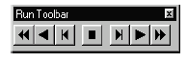It has been noted that there have been only minor attempts to produce input interfaces mirroring the concepts and data structures of the algorithms. In most cases, user interaction and output visualization are not separate. The system only offers a simple toolbar that allows the user to reset the algorithm and go forwards and backwards; sometimes redo and undo functionality is implemented, but no context-dependent navigation facilities are provided.
Figure 1: Typical execution interface
Consequently, it seems promising to replace the standard control using mouse clicks on graphic displays with alternative ways to generate concept keyboards (CKs) mirroring the inherent logical structures of the proposed algorithm. Concept Key-boards are keyboards with a reduced set of keys, but each one will trigger a more complex action in the context of the task being accomplished by the system. For example, the pressing of a single key may cause a sorting algorithm animation to exchange the positions of two elements in the array. Experience with CKs will help a student to understand how an algorithm works by allowing him to become involved in the execution of the algorithm and to navigate through the data structure. The user's attempts to perform actions on algorithms and data structures are reflected by changes in the visualization or another form of output like textual or acoustic information. This enables us to provide users with interfaces that enhance the comprehension of the algorithm being presented and that are even suitable for people with sensory disabilities, since the output information uses not only the visual but also the acoustic channel.
Our methodology is summarized in the following concepts, which can be used to create other interaction and reception modes in parallel to classic control through buttons and menus:
Define a level of detail the user is supposed to learn about the algorithm and choose a corresponding implementation of it. This means defining the operations the learner should be aware of and implementing them as a single function or method.
• Develop a suitable CK for the algorithm implementation by redefining keys or creating special button schemes on a graphic tablet. Then the keys represent the basic operations performed by the algorithm.
• Develop a spatial arrangement of the keyboard that mirrors the calling hierarchy of the procedures or methods of the algorithm. Implement a tool that delegates this task to the learner.
• Use icons or earcons to enhance the functionality of a specific key area design.
• Let the user choose which step should be executed at any stage of executing the algorithm.
• Define appropriate output channels combining a visualization with natural speaking or text.
• Implement an efficiency control which gives users optional feedback about the quality of their solutions.
This paper is an enlarged version of [2], [3], [6] with new results concerning the evaluation and forthcoming work. It introduces the notion of concept keyboards in algorithm animation. First, different ways of implementing concept keyboards are discussed. We then present a case study for the implementation of well-known algorithms using this new approach. We explain our idea and realization of the automatic generation of concept keyboards and conclude with a report on recent tests with students leading to our conclusions.
2 Concept keyboards
The interaction between the user and the algorithm can be implemented with a traditional keyboard present on every computer. The problem with these kinds of keyboards is that keys do not give the user a clue as to the meaning of the functionality that will be executed by pressing them. The keys are labeled to help users differentiate between them and determine which one must be pressed, but the problem of this approach is that there is no relationship between the key and the action that will be executed as a consequence of pressing it. This is one of the reasons for introducing the use of the concept keyboard. On a concept keyboard, each key has a special meaning (concept) associated with it instead of just a label. Therefore, a concept keyboard has only the keys necessary to use the keyboard in the intended way and can be customized with additional information for the user. In the present work the event-driven approach will be used to connect the visualization with the implementation of the algorithm or data structure [11]. Each key of the concept keyboard will be mapped to the execution of an existing method available in the algorithm implementation. In order to choose the interesting events (those which are crucial for understanding the algorithm), the designer has a simple graphic user interface displaying the available actions, and allowing him to select the relevant ones. Concept keyboards are used in different contexts. Often, compared with a normal keyboard, keys are broader and their number is reduced. They are used to trigger more complex semantic actions over the system in which they were implemented. Special software supplied allows one to redefine the function of each key and to regroup keys into fields of differing size.
Another way to implement concept keyboards is by programming touch screens or tablets. It is possible to associate them to individually shaped domains or icons with textual or graphic content. Their functionality also includes the launching of sound files or programs. Pens or fingers press the keys, and a prerecorded sound can be played or a picture displayed when they are pressed. Alternatively, the fields can also be accessed with push buttons or with joysticks. Objects can be placed over sensitive areas of the concept keyboard with different overlays. These can be produced by a kind of drawing program or selected from a large picture library. The IntelliKeys overlay keyboard [http://www.inclusive.co.uk/catalog/intkeys.sht] is a commercial product which provides physical, visual and cognitive access for people with a wide range of disabilities.
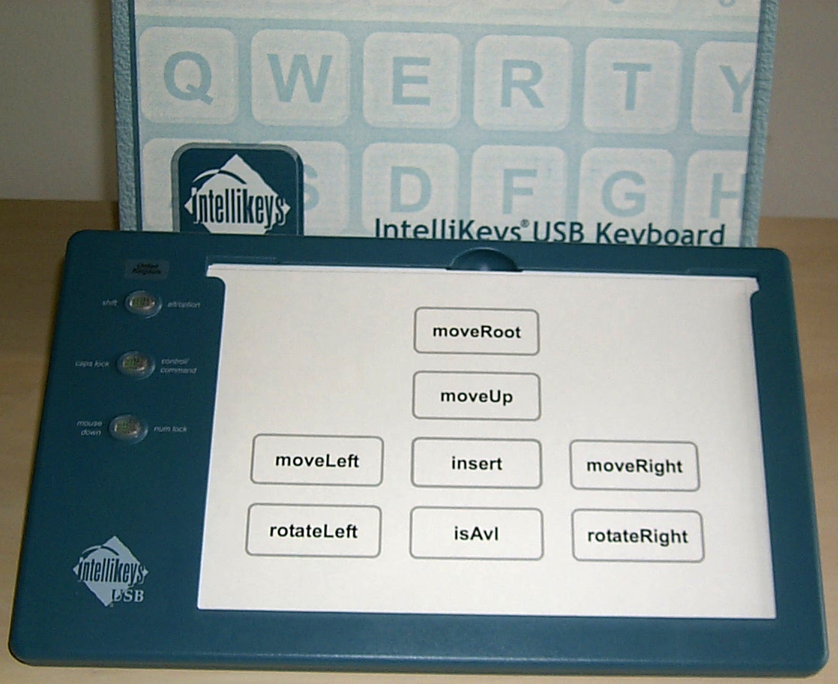
Figure 2: Concept keyboard for AVL-algorithm
The concept keyboard is considerably simpler to manipulate for children or impaired people. Since keys are bigger, they are suitable for people with residual sight. For totally blind people tactile exercise sheets (called overlays) are installed on the concept keyboard. Other applications are intended for students with learning difficulties. Our working hypothesis first introduced in Baloian and Luther [4], [5], [7] will be that not only sighted but also impaired users should navigate within our systems through new or augmented interfaces, using enhanced perception tools to achieve algorithm animation and visualization. To support multiple types of users with multiple types of interfaces, it is necessary to achieve the paradigm of a strict separation of view and control. Thus, it seems worthwhile to think about adequate concept keyboards supporting direct navigation on internal logical structures. This approach helps the user rebuild the original structures in mind as far as possible. In any case, it is well known that blind people develop special forms of navigating within an unknown environment and represent spatial structure with cognitive difficulty [5], [6]. This is the case in the real world as well as in virtual computer-based environments. Evidently, sighted users are not excluded; on the contrary, we claim that complementary perception channels and navigating facilities will represent a real enhancement for “normal users”.
To achieve this goal, we create appropriate keyboards consisting of well-arranged key areas combined with expressive icons and earcons that allow direct interaction with model objects. An earcon characterized by a representative melody can be added to any iconic control object. Earcons are abstract musical tones that can be used in structured combinations to create auditory messages. In 1989 Meera Blattner et al. [8] introduced earcons as nonverbal audio messages to provide information to the user about computer objects, operations or interactions. Earcons are constructed from simple, easily recognizable melodies also called motifs. Interfaces augmented by these complementary perception channels do indeed provide better comprehension.
3 Semi-automatic generation of the concept keyboard: principles
The system was implemented in Java, so we will describe it by their classes. The basic design for the system was the Mediator design pattern. This manager is based on an interface (ManagerInterface) that describes the common methods allowing coordination of the visualization, the algorithm implementation, the information input and the CK generated.
The Mediator design uses a ‘director’ in charge of controlling the communication between multiple ‘colleagues’. Each of the windows (panels) that present the configuration steps, act as ‘colleagues’ and the class ConfigurePanel is the ‘director’ class. The panels notify the director class to advance to the next or previous step, depending on the selection made by the user. The principal class implements the algorithm, which is loaded on the fly by reading its class name and location. The Reflection API allows a Java application to acquire the definitions of classes and operate on them at runtime without having them available at compile time. The library supports the instantiation of a class from its text name, acquiring information on a class and calling methods on an object. Once an instance of a class has been created, the user can access meaningful methods that execute the algorithm action-by-action with a certain granularity for manipulating the data structure. We use existing implementations of AV and add concept keyboards to control a step-wise or method-wise execution of the algorithms. The ideal requirement for the concept keyboard would be that it should be generated directly from the code implementing the data structures and algorithms over them. If the system has to generate the concept keyboard of an algorithm by automatically analyzing the code of its implementation, it will certainly come out with data structures’ declarations defining fields and operations that are needed to implement the complete system but are not necessary to understand the algorithm and/or data structure to be studied by the learner. On the other hand, the use of parameters in the implementation of methods for traversing or modifying the data structure may also complicate the generation of a simple but meaningful concept keyboard. Instead of trying to develop a method for a fully automatic generation of the concept keyboard we resort to a semi-automatic procedure and impose certain requirements on the implementation code. The first requirement is that methods should be implemented considering the object they reference as an intrinsic parameter. Instead of using methods that receive the object on which they operate as an argument, e.g. rotate(x) with x being the left-hand or the right child, a rotateLeft() and a rotateRight() operation should be declared. A second restriction is that each object used as an argument for the methods to be used in the concept keyboard must have a constructor that receives a string as an argument. This restriction allows the values of the elements of the data structure to be set in a more general way. An exception to this rule is simple data types in Java with corresponding wrapper classes that permit the construction of an object using a string.
We realized that, with just a few considerations, the creation of the CK can be independent of the implementation. Every implementation must have a method in charge of displaying the representation of the algorithm or data structure in a graphic or acoustic way. Algorithms that do not provide a visual (graphic) representation of the data structure have to be adapted in order to show this information graphically. This can be solved with a few modifications to the algorithms for the purpose of implementing their graphic visualization. In order to make the visualization as independent of the implementation as possible, we propose that each algorithm implements the methods described in the abstract class GraphObject (see below). This class defines a common name for the method in charge of drawing the elements as well a common constructor used by the system. The constructor that receives a string is used when the algorithm uses a startup file.

public abstract class GraphObject {
protected int width, height;
// Implicit constructor
public GraphObject() {}
// Used in loading a startup file.
public GraphObject(String filename) {
this();
}
public abstract void draw(Graphics graphics);
}

Furthermore, it is necessary to standardize the way the algorithm receives an optional startup file selected by the user. Full implementation details are reported in Middleton [29].
The layout generated should be tested on several benchmark examples. It is important that the new interface can be used to revise and enhance existing AAs and to analyze the dominant role of visualization in the perception process. To this end, the designer has to consider existing packages of animation frameworks. There are several repositories of AVs [12], [31] and WWW-pages containing links to collections of AAs [36]. There are also evaluations or votes by users. We believe that good implementation leads to a good CK and vice versa, independent of the visualization.
The following example can be used to gain insight in the appropriate form of a Java package of an AVL-tree:

package avltree;
.....
public class AvlTree extends GraphObject {
/* Insert an element in tree */
public void insert(int x) {... }
/* Insert an element in an AVL tree */
public void insertAVL(int x) {...}
/* Move to the root */
public boolean moveRoot() {...}
/* Move to left node */
public boolean moveLeft() {...}
/* Move to right node */
public boolean moveRight() {...}
/* Move to upper node */
public boolean moveUp() {...}
/* Return current node's value */
public int current() {return position.value;}
/* Rotate current node to the right */
public boolean rotateRight() {...}
/* Rotate current node to the left */
public boolean rotateLeft() {... }
/* test if tree is an AVL tree */
public boolean isAvl() {... }
}

The steps described above are necessary in order to define the number of keys a CK for a certain algorithm will have and which actions will be performed with them. Now it is necessary to define a convenient layout for these keys, which will be arranged over a graphic window or a graphic tablet, or implemented through overlay programming of a standard enhanced keyboard. Creation of the CK's layout should be based on the methods defined in the implementation of the algorithm. In order to support this process more or less automatically the system takes the following steps:
- The system will take the interface file and generate one key for each method labeled to indicate the method’s name.
- It will generate a board according to a grid in an 8-neighborhood or a spiral topology, depending on the designer’s choice.
- The designer will determine the location of each key by ‘drag-and-drop’ of the keys. It is highly recommended to place keys according to their names, for example, a key labeled ‘rotate_right’ or ‘move_right’ should be placed at the right. Therefore, the designer has to choose good names for the methods in order to indicate the position of the launching key relative to the focus position.
- Each key may call a method and/or play a sound file.
The generated layout should be tested on several benchmark examples. Then, statistics on the number of calls should be used to influence the distance between the corresponding key and the center point. The following figure 3 resumes the keyboard creation process.
The purpose of this application is to generate concept keyboards and then use them to visualize different algorithms. One of the objectives of the project was to allow the creation of the concept keyboards using existing implementations and introducing as few modifications as possible. The system is divided into two stages: Configuration of the concept keyboard and Visualization of the Algorithm (see Figure 3).
Figure 3: System stages
In the first stage, the configuration of the concept keyboard, the designer must determine the main characteristics of the concept keyboard that will be generated. In the second stage, the final user will interact with the concept keyboard in order to visualize the algorithms and data structures.
3.1 Configuration of the Concept Keyboard
During the Configuration stage, the user acts as a designer, selecting the methods within the class of the implemented algorithm that will be necessary to execute it with a certain granularity (see Figure 4). As stated in the previous chapter, there are a few restrictions that must be satisfied by the implementation. These will be discussed in detail later. The system displays a list of the available methods of data structure and the option of complementing the information with a description of each of the methods.

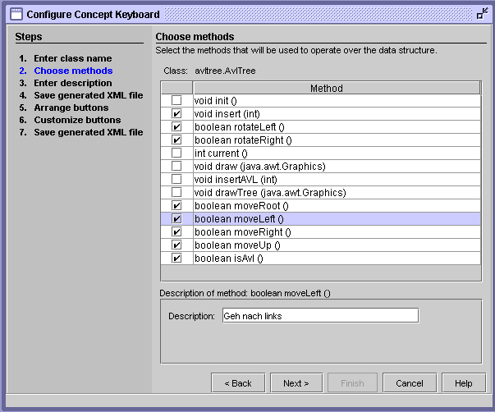
<?xml version="1.0"?>
<dataStructure>
<className>
avltree.AvlTree
</className>
<action id="0">
<description>
Rotate current element to the left
</description>
<methodName>
rotateLeft
</methodName>
<methodReturn>
boolean
</methodReturn>
</action>
<action id="1">
<description>
... ...
</action>
</dataStructure>

Figure 4: Choose methods – Configure CK Figure 5: Data XML File

After selecting the desired methods, the system generates an XML file containing them. This file describes the data structure by specifying the characteristics of each of the selected methods with a description, the parameters they receive, the return value, etc. (see Figure 5).
During the second stage of the configuration, the user designs the layout of the Concept Keyboard. This process consists in determining the position of each of the keys on the keyboard. The user drags and drops the buttons representing the “actions” of the algorithm to positions on the keyboard. The keyboard is initially represented by a 5×5 grid which can be extended to any M×N grid or be freely generated in a forthcoming version. The idea is that the designer groups the buttons of closely related actions together. As explained above, the distribution of the keys can be modified in accordance with the results of usability tests.
The keys on the keyboard can be customized by changing the labels and optional sounds associated with them. Each key can have two different sounds associated with it: the "Over sound" will be played when the user "passes over" the key, and the "Click sound" will be played when the key is pressed. Furthermore, an optional start up file can be specified that describes the initial state of the underlying data structure (see Figure 6). At the end of this process, the system generates the second interface file that will be used to describe the concept keyboard, denoted as the Keyboard XML file (see Figure 7b).

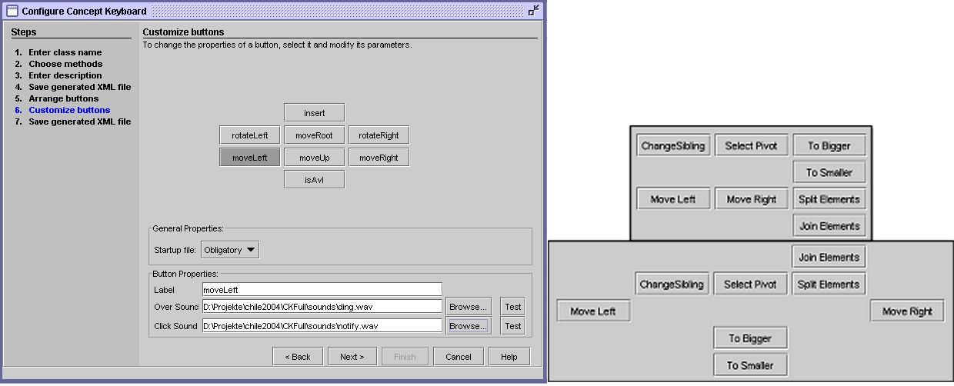
Figure 6: Keyboard customization Figure 7a: Different keyboard layouts for Quicksort

?xml version="1.0"?>
<keyboard>
<className>
quicksort.Quicksort
</className>
<startup type="2">
</startup>
<dimension>
<rows>
5
</rows>
<columns>
5
</columns>
</dimension>
<keys>
<key>
<methodId>
0
</methodId>
<location>
<row>
2
</row>
<col>
0
</col>
</location>
<label>
moveLeft
</label>
<sound type="over">
<filename>
</filename>
</sound>
<sound type="click">
<filename>
</filename>
</sound>
</key>
<key>
……
<methodId>
7
</methodId>
<location>
<row>
0
</row>
<col>
3
</col>
</location>
<label>
joinElements
</label>
<sound type="over">
<filename>
</filename>
</sound>
<sound type="click">
<filename>
</filename>
</sound>
</key>
</keys>
</keyboard>

Figure 7b: Keyboard XML File for the second layout and QuickSort
3.2 AV using Concept Keyboards
During the visualization of the algorithm, the user can load different algorithms and their corresponding keyboards. Each of the algorithms can have different concept keyboards, depending on the actions the user can execute. Furthermore, the system allows the user to load different layouts of the same concept keyboard for each of the algorithms (see Figure 7a).
This allows the designer to create different concept keyboards for the same algorithm depending on the characteristics of the group of students that will use the system or the results of usability tests. Depending on the purpose of the study, the designer may want to create a concept keyboard with some actions and another with others depending on the granularity of the methods.
It is also possible to load a step-by-step keyboard and the start up file (if the algorithm allows it) to change the initial values of the graph, tree, etc. in order for the student to have different problems to solve.
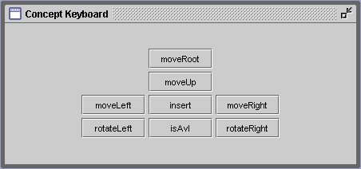
For students who are not aware of the algorithms, the concept keyboards are predefined by the designer. They can choose among different layouts. More experienced students are allowed to define layouts too. This is not only a matter of spatial arrangement, but also of the possibility to choose aiming at a greater detail in algorithm exploration. For example, the method that selects the pivot element in QuickSort could be executed automatically by the system or alternatively controlled by a special key on the created keyboard.
Figure 8a: Concept Keyboard window
In the visualization of the algorithm, the system displays three windows:
- Concept Keyboard: shows the corresponding concept keyboard. Each key represents a functionality allowing the user to manipulate the algorithm or data structure. Some functionality may require the user to enter some information (for example the value of a new element). To do this, the user can use the Input Area (see Figure 8a).
- Input Area: allows the user to input data for the various actions. This window is also used to give the user feedback on the results of the various actions (see Figure 8b).
- Draw Area: displays the graphic output of the algorithm or the graphic representation of the data structure (see Figure 8c).

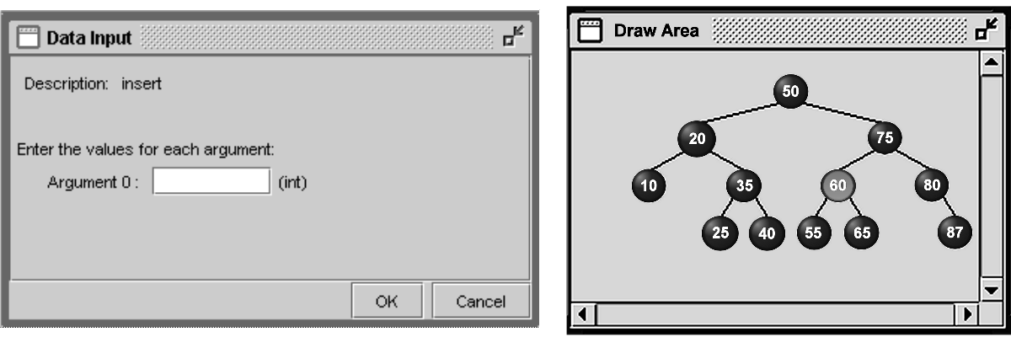

Figure 8b: Data input window Figure 8c: Draw area window
One of the main objectives of our work is to make the creation of the concept keyboard as simple as possible by separating the visualization and layout of the concept keyboard from the way the algorithm is implemented.

4 Implemented algorithms

In the following we will present several well-known examples of animated algorithms. The examples are classified under themes such as sorting, searching, graph algorithms, string processing, image processing and others. We have selected algorithms presented in a standard course on Algorithms and Data Structures and have tested the system with a real hardware CK as well as a virtual CK realized on a WACOM graphic tablet and on the screen.

4.1 Tree structures
There are many algorithms related to tree structures. Most of these algorithms try to solve the problem of inserting, deleting or searching nodes of the tree efficiently, hopefully in logarithmic time. From these algorithms, we chose to implement two: AVL trees and binary heap trees.
4.1.1 AVL Trees
An AVL-tree is a balanced binary tree proposed by Adelson-Velskii and Landis. It is not perfectly balanced, but the pairs of sub-trees differ in height by at most one. Insertion, deletion and search take logarithmic time. Implementations of AVL-tree insertion may be found in many textbooks and are a little bit tricky. An extra attribute (the difference between the heights of its left and right sub-trees) for each node indicates whether the tree is left-heavy, balanced or right-heavy. If the balance is destroyed by an insertion, we check the nodes for violations ascending from leaves to the root and focus the first node with difference of heights of its subtrees ≠-1,0,1. Depending on the structure of the sub-trees different standard rotations are performed to correct the balance: a simple rotation to the left-hand or right-hand side or double rotations equalize their height by cutting a subtree and moving it across to become the child of the upper node.
To do this work and to navigate on the tree we have configured the concept keyboard shown in Figure 8a. We used a standard JAVA-coded implementation of AVL-trees with the AVL-class and all relevant methods. This implementation defines a set of actions that can be executed over the AVL-tree. Although the implementation considers many methods, the ones considered useful for the learner are the following.
- insertAVL(int): inserts an element in the tree, keeping the AVL condition of the subtrees
- insert(x): inserts an element in the tree, without the restriction of the AVL tree.
- moveRoot(): moves focus to the root.
- moveUp(): moves focus to the parent node.
- moveLeft(): moves focus to the left child.
- moveRight(): moves focus to the right child.
- isAVL(): shows if current tree is an AVL tree.
- rotateRight(): rotates current node to the right.
- rotateLeft(): rotates current node to the left.
The Figure 8a proposes a keyboard containing a subset of these methods. The Figure 8c shows a real situation after the insertion of several nodes and the execution of a few rotations.
The configuration program generates the keyboard using the XML-layout file, while the visualization program provides the interface to build an AVL tree and launch the actions. All user actions are written down in a protocol file.

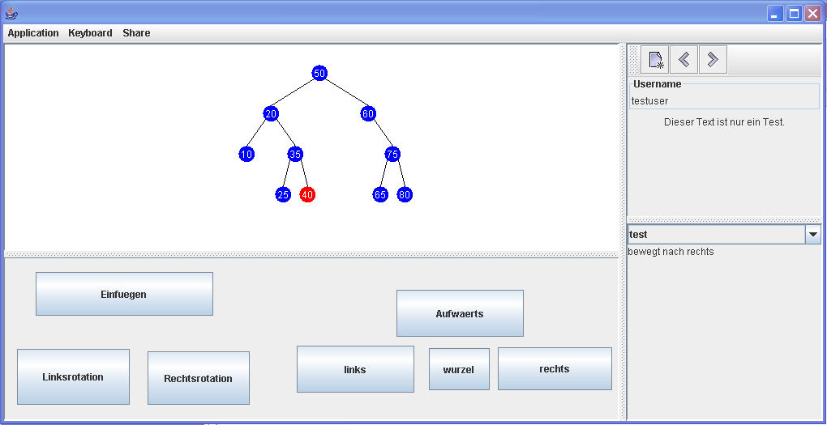
Figure 9: New AVL-implementation with freely configurable concept keyboard
4.1.2 Heap Sort

A heap sort stores n entries in a binary tree. Then beginning at the end and going on from right to left, the heap structure is established by comparing and exchanging children nodes and their parents. Arriving at the root of the tree, the first element of the sorted list is found and exchanged for the last element. The next steps are repeated until the complete list is sorted. The root element sinks to this right position, the heap structure is again reached and the new root exchanged. Several authors provide only two methods: ‘Build heap’ and ‘Move root to sorted list and reheap’. For the purpose of this work, we configure the concept keyboard detailed below (see Figure 10).
A slightly different keyboard layout can be derived for implementation by Faltin, whose PhD-thesis [20] provides a complete analysis of Heapsort and develops an interactive form of learning, programming, simulating and visualizing this algorithm. Two additional keys ‘Find (smaller) child’ and ‘Swap child’ realize the Heap condition for a node and its children.
Beginning with the actions "insert" and "append" a tree can be built successively (see Figure 4). If the tree has the heap property, the new node is inserted such that the heap property holds for the tree. Otherwise, the new element appears at the end of the tree.
If the heap property is lost, then beginning at the end and going on from right to left, the heap structure is established by comparing (findChild) and exchanging child nodes and their parents (swapUp). Arriving at the root of the tree, the first element of the sorted list is found and exchanged for the last element (moveRoot). The next steps are repeated until the complete list has been sorted. The root element sinks to this correct position (Sink), the heap structure is again reached and the new root is exchanged (moveRoot).

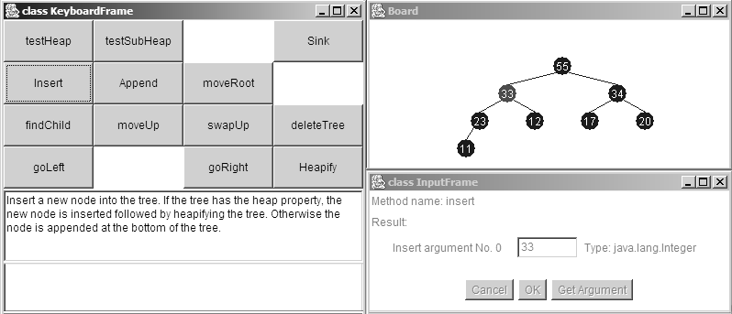
Figure 10: Virtual CK for the HeapSort algorithm

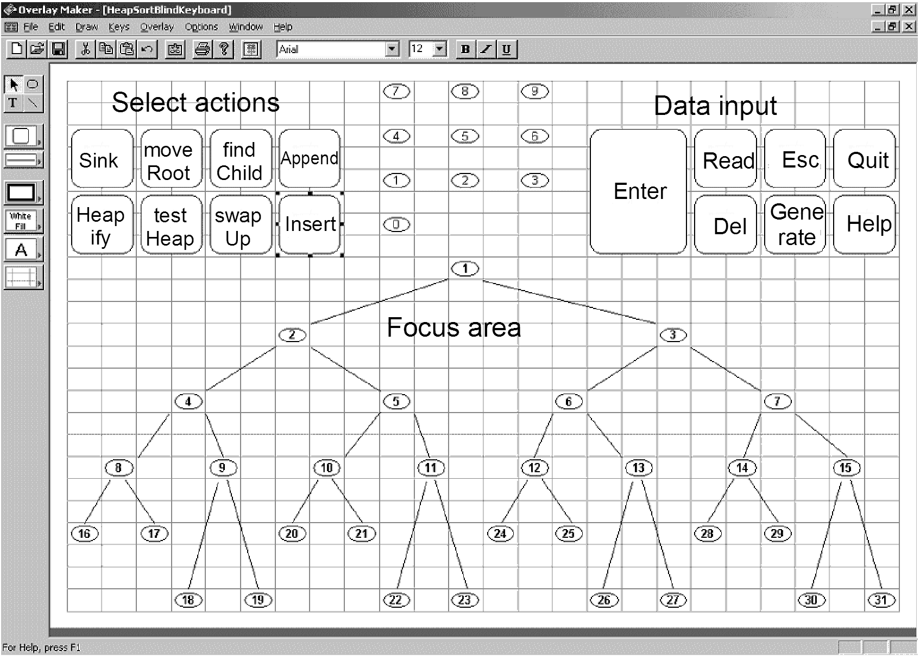
Figure 11: Tactile overlay for CK and the HeapSort algorithm

Figure 11 shows a possible second application with the configuration of an overlay intended for the CK. The focus area allows a visually disabled person to feel the positions within the tree. The nodes are labeled with Braille letter signs or rough textures accompanied by speech output. The action selection and data input areas are designed in an analogous way by using tactile symbols. Each action affects the data structure and leads to an acoustic output identifying the new focus, the content of a node and the resulting number of nodes. It should be mentioned that only information on local changes conveys a general understanding of the current tree structure. Finally, this configuration can be complemented by the visualization of the tree discussed above.

4.2 Sorting algorithms
Sorting a set of data in ascending or descending order is of great importance in every day problems as well as in theoretical studies. There are different approaches to solving this problem. Some of these approaches use the concept “divide and conquer” in order to divide the main problem into “smaller” and “simpler” problems that can be easily solved and then reconstruct the main problem. To implement this kind of solution, recursive algorithms are used, which are often difficult to understand for students new to algorithm studies. This is one of the reasons why we decided to implement the Quicksort algorithm and test the comprehension obtained by different students.

4.2.1 Quicksort algorithm
The Quicksort algorithm was invented by C.A.R. Hoare in the mid-sixties and is still one of the most efficient sorting algorithms. The algorithm can be described as follows, assuming that the elements are stored in an array (see Figure 12):
• One of the elements of the array is selected as the pivot. Some implementations select the pivot randomly, and others choose the median of three elements. Our implementation al-lows the user to determine which element will be used as the pivot.
• Each of the elements is ‘moved’ inside the array in order to have the smaller elements at the left of the pivot and the bigger ones at the right.
• Finally, each of the sub-arrays that were created (elements smaller and bigger than the pivot) is sorted recursively.
In theory, this recursive process stops when each of the sub-arrays has zero or one element. A more efficient implementation uses one pointer each at the start and end of the sub-array. Both step towards the middle and swap large elements near the start with small elements near the end. Furthermore, remaining sub-arrays with fewer elements are sorted by insertion.
In our work, the implementation we made of the Quicksort algorithm is based on displaying an array of elements, and the user can navigate through the elements by moving to the left and right. The user can select the pivot and move the elements. The user can execute the following actions:
- moveLeft(): moves current position of the “cursor” to the left. This allows the user to navigate through the elements.
- moveRight(): moves the actual position to the right.
- selectPivot(): selects the current element as the pivot. This permits the user to select any of the elements in the array as the pivot, so the user can study how the algorithm works, depending on the pivot chosen.
- moveToBigger(): “moves” the current element to the right of the pivot in order to have the elements larger than the pivot at the right.
- moveToSmaller(): “moves” the current element to the left of the pivot with the elements smaller than the pivot.
- splitElements(): this is used when all the elements have been moved so that the smaller elements are at the left and the bigger ones at the right. Thus, two smaller arrays are created, showing how the bigger problem was divided into simpler ones.
- changeSibling(): allows the user to move from one sub-array to the other.
- joinElements(): is used in reversing the process with the sub-arrays already sorted.
The concept keyboard we propose is presented in Figure 12. Figure 13 shows an example of the visualization of the Quicksort algorithm.

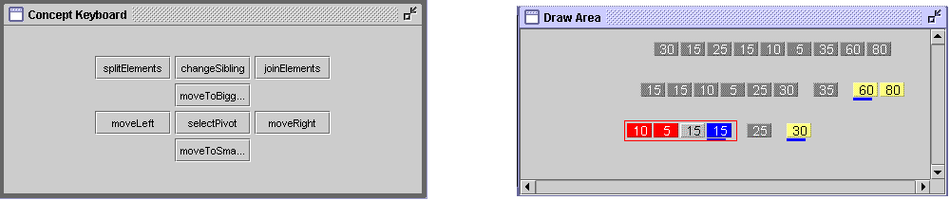

Figure 12: Quicksort — concept keyboard Figure 13: Visualization of the Quicksort algorithm

4.3 Graph algorithms
Graphs represent a set of nodes connected by a group of arcs (edges). Usually, each arc has a value associated with it that can represent the distance between the nodes. Two of the most common problems that can be solved using graphs are determining the minimum distance, or shortest path, between two connected nodes in a graph with directed arcs and finding the smallest set of arcs that connect every node in an undirected graph.
We implemented three classical graph algorithms. Dijkstra's algorithm finds shortest paths from a single node to all other vertices of a graph. Kruskal’s algorithm is one of the minimum spanning-tree algorithms. It is known as a greedy algorithm, because at each step it chooses the cheapest edge to add to the constructed subgraph. Rather than create a subgraph one edge at a time, Prim’s algorithm builds a tree one vertex at a time.

4.3.1 Shortest Path (Dijkstra’s algorithm)
To solve the problem of determining the shortest path, the most popular algorithm is the one presented by Edsger W. Dijkstra, known as “Dijkstra’s algorithm”. There are many interpretations of the nature of the problem solved by Dijkstra’s algorithm, with some authors characterizing it as finding all the shortest paths connecting any two nodes u,v of the graph and others as finding the shortest path between given starting and ending nodes. Our implementation considers the second approach since it is simpler to understand and the problem of finding all the paths is just an extension of the simpler problem. Then the algorithm works by constructing successively the distances d[v] of the shortest paths from a starting point s and by considering the neighbors of the nearest node u. For these neighbors v the distances d[v] are computed via d[u] + w[u,v] if there is no current value d[v] or if d[v] > d[u] + w[u,v]. Here w[u,v] denotes the weight of the edge joining u and v. This basic operation is called relaxation and is applied at most once for each newly reached node. Based on this implementation, we designed a concept keyboard that will allow the user to navigate through the arcs and nodes of the graph and determine which node should be selected according to Dijkstra’s algorithm.
The actions available are the following:
- selectNextEdge(): moves the current position to the next available edge.
- selectPreviousEdge(): moves the current position to the previous available edge.
- addNextNode(): adds the selected node to the set of “reached nodes” and updates the total cost of the reached nodes.
- removePreviousNode(): allows the user to remove the last node appended.
- showPath(): shows the current path based on the nodes selected by the user.
- showShortestPath(): shows the corresponding shortest path, using Dijkstra’s algorithm.
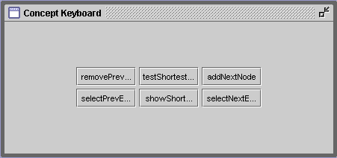
- testShortestPath(): tests whether each of the steps taken by the user when selecting the nodes satisfies the conditions stated in Dijkstra’s algorithm. This is useful for testing whether the user really used the algorithm or just chose the nodes by inspection.
Figure 14: Dijkstra’s algorithm -- concept keyboard
One of the concept keyboards proposed for this algorithm is shown in Figure 14. The visualization of the graphs used in the Dijkstra algorithm is shown in Figure 15.
4.3.2 Minimum Spanning tree
Another common problem is the one of finding the minimum spanning tree, i.e. finding a set of arcs connecting all the nodes where the sum of their cost is minimum, which connects all the nodes, without creating cycles (loops between nodes). To solve this problem, we decided to implement two algorithms that can be used to find this tree: the Kruskal algorithm and the Prim algorithm. Both of them find the tree with minimum cost but use different approaches.
The Kruskal algorithm starts with a forest of n trees where each tree consists of each of the nodes of the graph. In each iteration step the algorithm picks the edge that has the smallest cost and does not create a cycle. Then, it connects the two small trees with the selected edge to create a bigger one. At the end of the process, the algorithm ends with one tree where each of the nodes of the graph is connected without forming a cycle.
The Prim algorithm begins at the edge with least cost and marks the two nodes it connects as “settled”. Then, in each iteration step, the algorithm adds the edge with least cost where one of the ends is marked as “settled” and the other end is not. This assures that no cycles will be created while picking the edges with least cost.

4.4 Differences with existing visualizations
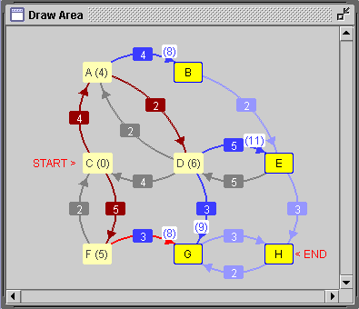
The use of concept keyboards allows a manipulation of the data structure that does not exist with most of the algorithm visualizations available for the students. Most existing algorithm visualizations allow users to execute the steps described in each algorithm but do not allow them to manipulate the data structure freely. For example, in the AVL example, the user can rotate any node in the tree although it may happen that the rotation does not help to create a balanced tree. This freedom permits users to try different actions and gives them a better understanding of what occurs when a “bad decision” has been made. For this reason, we propose that each implementation has a “test” button, so that the user can manipulate the data structure and execute the algorithm freely and then test whether the decision taken was correct or not (for the algorithm being studied). By the way, by providing the user with corresponding complementary actions, the undo problem is solved in an elegant manner.
Figure 15: Visualization of the Dijkstra algorithm
5 Related work
We will not review past AA and AV systems referenced in books on algorithm animation [9], [33], [34] and three books on software visualization edited by John Stasko et al [35] and Stephan Diehl et al [15], [16]. Rößling [32] describes methods of generating animation and classifies known systems. There are several repositories of AVs [12], [36] and WWW-pages containing links to collections of AA. Feiner and McKeown [21] have developed an experimental testbed called COMET (Coordinated Multimedia Explanation Testbed) for the interactive or automated generation of multimedia explanations that combine text and three-dimensional graphics on the fly. In response to a user request for an explanation, COMET decides which information should be expressed in which medium.
The project WIP (Knowledge-Based Presentation of Information, http://www.dfki.de/imedia/wip/) aimed at the development of a presentation system that is able to generate a variety of multimedia documents and to present the same information in different ways, depending on the generation parameters and the individual users in particular communicative situations.
Our work was inspired by M. Eisenberg [19], who offers a number of interface guidelines for mathematical algorithms and suggests ways to provide the user with flexible means for both controlling and understanding the algorithm in question.
In Bridgeman et al [10], a platform-independent e-learning tool, PILOT, was designed; it allows for the generation of random instances of a problem, a user interaction specifying a solution, an evaluation of solutions and a generation of correct solutions to the problem. Our work has points in common with initiatives concerning XML user interface languages like XIML (http://www.ximl.org/) to configure interfaces. The recently presented MatrixPro system [26] allows the instructor to interact with any data structure already implemented in a library. The framework allows users to create animation sequences and to combine them seamlessly. The main view of the program consists of a menu bar, a toolbar and the area of the visualizations.
Recent work, such as the frameworks Ganimal [13], [14], [17] and LEONARDO [11], uses the event-driven approach to specify the relevant events associated with an algorithm or data structure. Another way to proceed was proposed by Hundhausen [22], [24], who conducted experiments with students who constructed their own AV made out of simple art supplies. In this work, a prototype language and system allows the specification of the AV in terms of spatial logic, postulates a novel interface that supports forward and backward execution and includes a new presentation interface that supports the dynamic markup and modification of an AV. Hundhausen, Douglas, and Stasko [23] classify the experiments that have been done in two categories in order to test the pedagogical benefit of using AVs.
Hundhausen observes that the experiments that allowed students to manipulate the level of involvement had significantly better results than the experiments that allowed them to manipulate the graphical visualization. He concludes that AV software does improve the comprehension level of students and specifically that “what learners do, not what they see, may have the greatest impact on learning” [22]. These observations support our hypothesis that in order to achieve better comprehension the student should be able to participate actively in exploring the algorithm.
Douglas and McLinden [18] use concept keyboard technology to teach early tactile reading. In an educational multimedia application dedicated to blind children. Archambault and Burger [1] report on a touch device as a concept keyboard. Tactile exercise sheets are installed as overlays on the concept keyboard. When the child presses an object placed on an overlay, multimedia events are triggered.
6 Evaluation
Through two phases of evaluation we gained initial indications of the value of the concept and ideas for further development. Interactive concept keyboard interfaces for the animation of algorithms offer a great variety of usage scenarios. Attempts to evaluate this new approach have to differentiate between these usage scenarios and clearly define which aspect of the approach to evaluate. For example, we can evaluate the usefulness or usability of the concept keyboard configuration process or its implementation in different devices, the educational benefit of different concept keyboard configurations for learners in comparison to other configurations or other forms of algorithm visualization. On a more detailed level different arrangements of keys on the keyboard or the appropriateness of different earcons may be tested.
Starting from the thesis that the educational value of algorithm visualization increases with the level of learner engagement it affords, the Working Group on “Improving the Educational Impact of Algorithm Visualization” [30] proposed a taxonomy of learner engagement with visualization technology and effectiveness metrics for evaluating different implementations. To determine the effectiveness of each of these kinds of visualization, it is necessary to differentiate between the levels of understanding learners can achieve. Furthermore, they proposed learner’s progress, course drop-out rate, learning time and learner satisfaction as possible measures. Regarding engagement, the authors differentiated between “No viewing”, “Viewing”, “Responding”, “Changing”, “Constructing” and “Presenting” as basic forms of learner engagement; these also compose a framework for empirical experimentation.
Regarding our software, “Viewing” occurs in all cases through the visualization in the draw area. Also, the software allows teachers to present and discuss cases and give students instructions on how to work with the software. Therefore, “Responding” is not explicitly build into the current design but may be easily supported if appropriate instructions or questions are given to the students. Students may then use the visualization and interaction as a resource for answering questions.
“Changing” or modifying the visualization is supported in more than one way. Firstly, students may enter new data into the structure, changing the problem to solve in the visualization mode of the software. Secondly, in the visualization mode, students and teachers can create and modify the startup file (a simple text file) to specify the initial values, e.g. the number of nodes and the costs of the edges, to be used in the visualization of the algorithm. Thirdly, teachers can configure the way the user can manipulate the data structure by defining concept keyboards for distinct teaching purposes and user groups. A particular strength of our system lies in the possibility to explore the working of algorithms on different (states of) data structures. It allows users to explore the life of the algorithms on the grounds of self-defined data in a self-directed way. Our thesis is that this self-directed exploration promotes a deeper understanding of the workings and limitations of algorithms as mentioned in Mandl and Reinmann-Rothmeier [28].
“Constructing” in the sense of the proposed taxonomy may be supported by the system depending on the visualization used as a basis for generating the concept keyboard. However, neither this nor the presentation of self-created visualizations is the objective of our system.
6.1 Comparison to web-based AV
In our approach the use of concept keyboards is closely linked to the highly interactive nature of the interfaces they provide for learners. Therefore, our first formative evaluation of the system focused on interactivity as a distinguishing feature. As a preliminary exploratory study, we designed standardized questionnaires with closed and open questions and exercises for students working with a pre-configured version of the concept keyboard and web-based algorithm visualization software. All 17 students volunteered (introducing a factor of self-selection) to participate in the study. An initial, “younger” group of eleven computer science students (aged 20 to 25) was drawn from a third year course on “Data Structures and Algorithms” at the Universidad de Chile. They had just been introduced to the Prim, Kruskal and Dijkstra algorithms in class and never used algorithm visualization software before. The second, “older” group of six post-graduate students additionally worked on Heapsort, AVL and Quicksort. They were given a brief refresher on the algorithms before the test. A number of web-based algorithm visualizations were available [36] and tried out alongside the concept keyboard software.
All participants considered some visualization software to be a necessary complement to what was taught in class. As qualitative feedback from the questionnaires, participants commented that they liked the interactivity of the concept keyboards, which enabled learner-driven problem-solving and exploration in case of doubt and also promoted deeper understanding. Without being explicitly asked, participants consistently favored “usability”, “interactivity” and “path selection” on the concept keyboard. “[It is] more user-friendly, understandable and interactive. It allows us to solve the problem and not just to visualize the algorithm” was one typical statement. Another student enjoyed the opportunity to test for himself whether he really understood the algorithm by trying special cases. Comparing the two kinds of visualization, all but one preferred working with the concept keyboard. (That one criticized interface aspects like the button representation on the screen and the inability to draw his own graphs in this version of the software as not being optimal for his learning purposes.) This may indicate a motivational advantage for our approach. However, some disliked the fact that the concept keyboard and algorithm visualization have, up to now, been represented on the same screen (which, in fact, reduces the intended conceptual advantage of using concept keyboards and, therefore, their usability). This point will be elucidated in a further test series using a real hardware keyboard or alternatively a Wacom tablet and a dual screen graphic processor.

6.2 Comparison to a step-by-step interface
As we are advocating for more involvement of the learner, we want to compare the step-be-step interface against the one proposed by this work. To really focus on differing levels of interaction as the distinguishing feature for educational benefit, a we used a reduced concept keyboard only allowing to go forth and back in the solution should for comparison (instead of conventional visualization software, which may confound results through different kinds of interfaces, visualization and extra information and features that are difficult to control or distinguish as covariant factors).
Therefore, the concept keyboard software was tried out again in a standard lecture on Algorithms and Data Structures (A&DS) at the University of Duisburg-Essen. The test group consisted of 18 students enrolled in different study programs. The system was used to create two kinds of interfaces: a step-by-step keyboard for the Quicksort, and the Kruskal and concept keyboards for the Dijkstra and AVL algorithms—together with two different start-up files for each problem.
The questionnaires used on the tests in Santiago were modified by adding more questions in a new format. In addition to open questions, which dominated the first evaluation in Santiago, students rated their level of agreement with a set of 16 affirmations on a five-point scale. The scale ranged from 1-5 after transformation, with low values indicating rejection and high values indicating agreement. Then they tried to solve four problems with the selected algorithms. Some examples of these affirmations are: Figure 16: Test problem of Kruskal’s algorithm
- “It is necessary to use algorithm visualization software as a complement to what was learned in class or tutorial.” (Median 4, Range 3-5).
- “My knowledge concerning the proposed algorithms is now better.” (Median 4, Range 1-5).
- “The tool provides better insight into the proposed algorithms and data structures.” (Median 4, Range 1-5).
- “Customized labels for the keys should be added.” (Median 4, Range 1-5).
- “Use a real alternative hardware keyboard.” (Median 2, Range 1-5).

After a short introduction to the algorithm visualization system, the students filled out some statistical data and estimated their knowledge of algorithms. Then they tried to solve a set of exercises by hand.
In a third step, students worked out eight problems using the Quicksort and Kruskal algorithms with the step-by-step keyboard as well as the Dijkstra and AVL algorithms with the concept keyboard. Then, students answered a complete questionnaire to describe their impressions and experiences with the new system. Finally, they were asked to solve a new set of exercises without using the system. A typical exercise was the following:

“Solve the following problem by finding the shortest path from C to H or, alternatively, finding a minimal weighted spanning tree from the start node to all other nodes. Select the right edges, write down the order in which you choose the nodes and edges, and write the distance into the boxes (see Figure 16).” Analysing the solutions to the exercises by observing and using qualitative feedback from the participants, we gained the following insights:

- The students with less knowledge preferred the step-by-step interface to the concept keyboard. This may result from the fact that the step-by-step interface does not require previous understanding of the algorithms. On the other hand, using the visualization with the concept keyboard led to better results in problem solving than the use of the step-by-step interface.
- Participants suggested increasing the number of algorithms presented and the existence of an extended explanation of the algorithm being studied.
- The students like to receive a verbal description of the characteristics and the functioning of the algorithm. Explanatory and help texts should be visible during the execution of the algorithm.
Though most did not miss a real hardware concept keyboard, they preferred to have larger buttons on th concept keyboard emulated on the screen to control the actions.

In general we received quite positive feedback from the students and strong indications of the value of our approach.

6.3 Comparison to a Wacom tablet
Although the data obtained so far did not yield a sufficient basis for statistically significant results, they encouraged us to conduct a more comprehensive test from November, 2004 to January, 2005. Nearly one hundred students with similar levels of knowledge in Algorithms and Data Structures answered a questionnaire after having worked with different implementations of the step-by-step and the CK interfaces. The CK interface was first given to them at the beginning but they had to design their own one afterwards.
A total of 59 tried out the hardware CK and a CK implementation on a Wacom tablet in. These students filled out the first part of the questionnaire concerning demographic data in advance. Neither the CK nor the step-by-step interface has been introduced to them before. At the beginning of the 60 minutes session there was a short introduction given by a supervisor. During 20 minutes, the test persons were working on two proposed problems concerning the AVL-tree or the QuickSort algorithm in a self-explorative way. Then they answered questions concerning the CK implementation on the IntelliKeys board and the Wacom tablet. After this, they worked during 20 minutes with the step-by-step implementation. At the end they further questionnaires were filled out concerning the following information:

- Demographic data and participation degree in the lecture
- Impressions received while working with the CK implementation
- Impressions received while working with the step-by-step keyboard
- Comparison of both implementations
- Configuring an own keyboard layout (only few students)
- Final appreciation

Most questions to rate both the CK and the step interface were noted in form of assertions and students should declare the degree of agreement. The scale ranged from 1 – 5 after transformation, with low values 1 and 2 indicating (strong) rejection (--) and high values 4 and 5 (strong) agreement (++). Negative answers to questions using a negatively assigned characterization were coded on the positive side of the scale. Further questions allowed free answers written down by hand. These utterances were transcribed but not introduced into this evaluation.
To systematize the evaluation, different items in the questionnaire were collected and allocated to different hypothesizes. Thus, a high rating of the assertion supports the hypothesis. The reference value is the average value 3, significant occurrence are stated if the mean derivation of the average cannot be interpreted as accidentally.
The following hypothesizes were investigated:

- Hypothesis 1 : The use of CK increases the comprehension of algorithms
- Hypothesis 2 :The enhanced exploration modes of the CK approach facilitate the learning process
- Hypothesis 3 :Visualizing algorithms with the CK is more motivating than working with the step-by-step keyboard
- Hypothesis 4 :The step-by-step keyboard is more appropriate for the beginners.

We grouped seven questions in relation with hypothesis 1 under the variable H1 ‘comprehension’. High values indicate that the CK stimulates the comprehension, whereas low values compromise the hypothesis. The mean value µ_{H1} = 3.79 and variance σ_{H1} =0.58 confirm the hypothesis. A further sampling T-test result in P≤0.001 (T=10.44) shows that the result is significantly different of the mean value which points to a positive evaluation of the CK.
The result for the hypothesis 2 (H2) was quite similar. The free exploration leads to higher concentration and does not result in wasting time even if there is a possibility to choose a wrong way to solve the problem. The variable H2 subsumes three items and was positively noted with µ_{H2}= 3.74 and variance σ_{H2} =0.82 (T-test: P≤0.001, T=6.96). People liked the opportunity to try unconventional solutions and to optimize their first attempts.
For the hypothesis 3 (H3) the three concerned questions related to this hypothesis were positively ranked with µ_{H3}= 4.26 and variance σ_{H3} =0.71 (T-test: P≤0.001, T=13.55). Moreover, these results are confirmed by the answer of 36 persons to question 53: they preferred learning algorithms with the CK compared to 22 students voting for the step interface.
In order to evaluate the hypothesis 4 two questions dealing with the acceptance of the CK and the step-by-step keyboard in the group of novice students were used. Whereas the CK collected both meanings leading to a neutral average value, the step interface was found quite appropriate by the freshmen (µ_{H4}= 3.92 and variance σ_{H4} =1.24; T-test: P≤0.001, T=5.69). It gives a clear orientation to the young inexperienced user (µ= 3.63 and variance σ =1.113). However, after the first experiences, the inflexible sequence of steps seems to be boring and the user prefers to choose himself the next action of the algorithm that modifies a freely chosen element within the data structure (Question 50, µ= 4.05 and variance σ =1.166).
As a concluding appreciation of the test sessions with the CK und the step-by-step keyboard the probands preferred the first one with 62.1 percent whereas 37.9 percent supported tthe step interface.
A further testing similar to the one taken in January 2004 of the software was performed with another forty persons who were divided in two groups using the more detailed questionnaires than the described above. In a pretest, three problems concerning the AVL, the QuickSort and the Dijkstra algorithms were to solve by hand, that mean without any support from computer software. Then these test persons worked out several standardized problems for the three algorithms using the CK or the step-by-step implementation, respectively, and filled out the corresponding questionnaires. In a posttest, similar problems were worked out by the test persons, this time again by hand. Afterwards, the remaining questions were filled out and some of the students were asked to triy out their own keyboard configurations. The student’s answers were evaluated using a point scale from zero to ten (best performance). For each problem the performance of each test person in the pretest and the posttest were compared by subtracting the obtained points. The two groups were labeled depending on the used interface. Then the scores obtained were transferred into a ranked list and the non-parametric Mann-Whitney test was applied. A test variable U and the ration z=(U-µ_{U})/σ_{U} was computed. This value was compared to a table of critical values for the normally distributed random variable z. In our study, we were unable to proceed with the usual 95% level of significance, but on a 91% level the group using the CK implementation performed better than the group using the step keyboard. The evaluation of the questionnaire confirmed the results obtained in the individual tests.
7 Further work and conclusion
In this work we have presented a way of visualizing algorithms which advocates for a more involvement of the learner. In this approach, learners are asked to chose themselves which actions are to be performed and when. The framework developed helps to build the visualization software of the algorithm starting from an implementation complying with few requirements. The software architecture implements a new controller design that allows users to select a class library on the fly, to instantiate objects and to call their objects. Input and output interfaces are configured through XML files. The system was evaluated at different stages and improved. From the last evaluation, which was also the most complete one, we can conclude that the “Concept Keyboard” approach we developed is really better at supporting effective learning of algorithms, at least under the conditions we carried on our tests. On the basis of empirical evidence and evaluation of the advantages of this specific implementations of algorithm visualization we invite teachers and learners to participate in establishing the use of these techniques as an integral part of the curricula in computer science education.
Using the results of this research a new version of the CK was implemented in which the configuration of the concept keyboard design largely enhanced by introducing freeform buttons shapeable in various ways. Furthermore there is now an online version with collects and evaluates user data taken from a special repository.
Standard control interfaces for algorithm animation were enhanced using appropriate concept keyboards to convey logical structures or data types to human minds. Optional dual or multiple interfaces improve human-machine communication and support sensory-disabled persons.
It was an important step to separate control, input and output channels by means of an adequate concept keyboard that can be used to process data structures and geometric models. To achieve a meaningful visualization, we focus on important information after a suitable abstraction process. The concept keyboards can be integrated in existing AA systems
Currently, we use this concept to implement software supporting the learning of interactive cryptographic protocols in a collaborative and participative way. Learners have to choose and trigger the necessary methods in the right order to produce and use secure cryptographic public and private keys interacting with each other, thus applying the principle of “more learner involvement” in algorithm visualization to a collaborative scenario. The system uses an interactive Turing machine, private workspaces to generate key words and to encrypt and decrypt messages and shared workspaces to execute the protocol. In a student project three protocols, the Wide Mouth Frog, the Feige Fiat Shamir and the Kerberos V protocol were implemented.
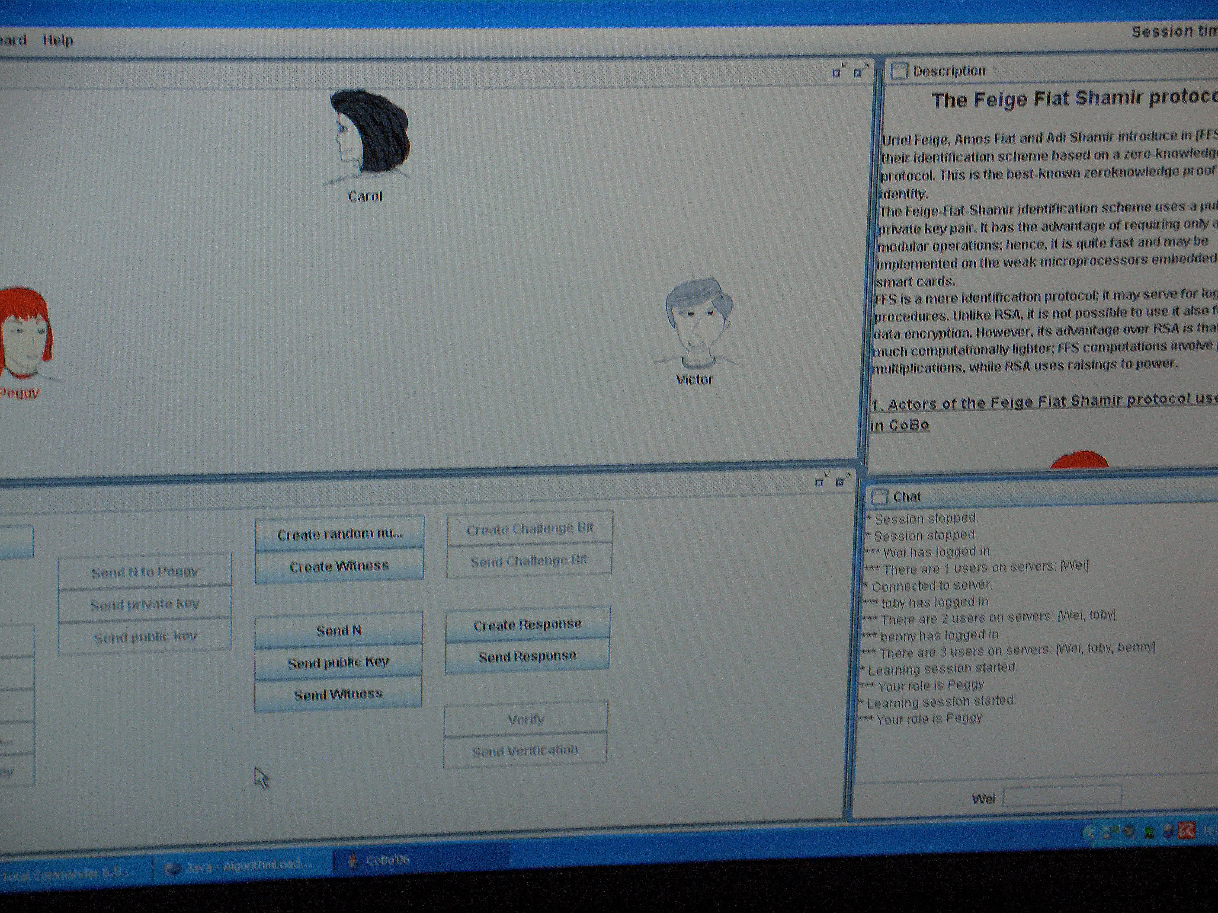
Figure 17: Feige Fiat Shamir protocol together with three actors.

8 Acknowledgements
This research and common multi-media software development for different learner communities are being carried out by the authors in the course of a current German-Chilean project funded by the German ministry BMBF and the Universities of Duisburg and (Santiago de) Chile.

References
1. A. Archambault, and D. Burger, TIM (Tactile Interactive Multimedia): Development and adaptation of computer games for young blind children. Workshop on Interactive Learning Environments for Children. Athens, Greece, March 1-3.
http://ui4all.ics.forth.gr/i3SD2000/Archambault.PDF
2. N. Baloian, H. Breuer, W. Luther, W. Chr. Middleton, Algorithm visualization using concept keyboards. Proc. ACM SoftVis’05, St. Louis, Missouri, May 14-15, 2005, pp. 7-16.
3. N. Baloian, H. Breuer, W. Luther, Chr. Middleton, Th. Pilz, Konzept-Tastaturen zur Algorithmenanimation. Informatik 2004, P. Dadam, M. Reichert eds. Beiträge der 34. Jahrestagung der Gesellschaft für Informatik e.V. (GI), GI 2004, 399-403.
4. N. Baloian, W. Luther, Various modeling aspects of tutoring systems for people with auditory disabilities. IFIP SECIII conference, July 22-26, 2002, Dortmund, in Informatics and the digital society, social, ethical and cognitive issues, eds. Tom J. van Weert, Robert K. Munro, Kluwer 2003, pp. 197-206.
5. N. Baloian and W. Luther, Visualization for the Mind's Eye. Workshop on Software Visualization, Dagstuhl, 20.-25.05.2001, Software Visualization, State-of-the-Art Survey LNCS 2269, (St. Diehl ed.) Springer 2002, pp. 354-367.
6. N. Baloian, W. Luther, Th.. Putzer, Algorithm Explanation Using Multimodal Interfaces. IEEE Press CS SCCC 2005, Valdivia, November 7-12, 2005, pp. 21-29.
7. N. Baloian, W. Luther, and J. Sánchez, Modeling Educational Software for People with Disabilities: Theory and Practice. Proceedings ASSETS 2002 conference, July 8-11, 2002, Edinburgh, Scotland, pp. 111-118.
8. M. Blattner, D. Sumikawa, and R. Greenberg, Earcons and icons : Their structure and common design principles. Human-Comput. Interact. 4 (1) 1989, pp. 11-44.
9. M. H. Brown, Algorithm animation. The MIT Press, Cambridge, MA, 1988.
10. S. Bridgeman, M. T. Goodrich, S. G. Kobourov, and R. Tamassia, PILOT: An interactive tool for learning and grading. Proceedings of the 31st SIGCSE Technical Symposium on Computer Science Education, ACM press, 1000, pp. 139-143.
11. P. Crescenzi, C. Demetrescu, I. Finocchi, and R. Petreschi, Reversible execution and visualization of programs with LEONARDO. Journal of Visual Languages and Computing 11, 2000, 125-150.
12. P. Crescenzi, N. Faltin, R. Fleischer, Chr. Hundhausen, St. Näher, G. Rößling, J. Stasko, E. Sutinen, The Algorithm Animation Repository. Proceedings of the Second International Program Visualization Workshop, 2002, Århus, Denmark.
13. St. Diehl, C. Görg, and A. Kerren, Preserving the Mental Map using Foresighted Layout. Proc. Eurographics – IEEE TCVG Symposium on Visualization, VisSym, 18-20 May 2001, Ascona, Switzerland.
14. St. Diehl, A. Kerren, T. Weller, Visual Exploration of Generation Algorithms for Finite Automata. In Implementation and Application of Automata, LNCS 2088, 2001, pp. 327-328.
15. St. Diehl and A. Kerren (Hrsg.), GI-Workshop Softwarevisualisierung 2000, Universität des Saarlandes, Saarbrücken, 2000
16. St. Diehl (ed.), Software Visualization, State-of-the-Art Survey LNCS 2269, Springer 2002
17. St. Diehl and A. Kerren, Generierung interaktiver Animationen von Berechnungsmodellen. Informatik - Forschung und Entwicklung, 17(1): 12-20, 2002. Springer.
18. G. Douglas and M. McLinden, The use of concept keyboard technology to teach early tactile reading. Eye Contact, Autumn (19) 1997, pp. 31-33.
19. M. Eisenberg, The thin glass line: designing interfaces to algorithms. Proceedings of the SIGCHI conference on Human factors in computing systems: common ground, ACM press, 1996, pp. 181-188.
20. N. Faltin, Strukturiertes aktives Lernen von Algorithmen mit interaktiven Visualisierungen. Dissertation, Fachbereich Informatik, Universität Oldenburg, 2000.
21. S. Feiner, S. and K. McKeown, Automating the generation of coordinated multimedia explanations. In IEEE Computer, 24 (10), October 1991, pp. 33-41.
22. C. Hundhausen, Toward effective algorithm visualization artifacts: Designing for participation and communication in an undergraduate algorithms course. Unpublished Ph.D. Dissertation, Department of Computer and Information Science, University of Oregon 1999. http://lilt.ics.hawaii.edu/~hundhaus/dis
23. C. Hundhausen, S. Douglas, and J. Stasko, A Meta-Study of Algorithm Visualization Effectiveness, Journal of Visual Languages and Computing, Vol. 13, No. 3, June 2002, pp. 259-290.
24. C. D. Hundhausen and S.A. Douglas, Low Fidelity Algorithm Visualization. Journal of Visual Languages and Computing 13(5) 2002, pp. 449-470.
25. A. Janser, Entwurf, Implementierung und Evaluierung des interaktiven Lehr- und Lernsystems VIACOBI für die Visualisierung von Algorithmen der Computergraphik und Bildverarbeitung. Logos, Berlin 1998. ISBN 3-89722-065-2.
26. V. Karavirta, A. Korhonen,, L. Malmi, and K. Stålnacke, MatrixPro - A Tool for On-The-Fly Demonstration of Data Structures and Algorithms. Proceedings of the IEEE International Conference on Advanced Learning Technologies (ICALT’04), IEEE, 2004, pp. 26-33.
27. W. Luther, Algorithmus-Animation in Lehr- und Lernsystemen der Computergraphik. In Diehl, St., A. Kerren (eds.). GI-Workshop Softwarevisualisierung 2000. Dagstuhl, 11.-12.5.2000, pp. 103-114.
28. H. Mandl, G. Reinmann-Rothmeier, Auf dem Weg zu einer neuen Kultur des Lehrens und Lernens. In Dörr G.; Jüngst, K. L. (eds.): Lernen mit Medien. Juventa-Verlag, Weinheim, 1998; pp. 193-205.
29. Chr. Middleton, Algorithm Visualization Using Concept Keyboards. Master thesis, University of Chile, 2004.
30. T. Naps (co-chair) et al., Exploring the Role of Visualization and Engagement in Computer Science Education. SIGCSE Bulletin inroads, Vol. 35, no 2, 2003; pp. 131-152.
31. G. Rößling, Kommentierte Sammlung von Algorithmenanimationen und Animationssystemen.
http://www.animal.ahrgr.de/Anims/animations.php3
32. G. Rößling, Key Decisions in Adopting Algorithm Animations for Teaching. In (van Weert, T.; Munro, K. R. Hrsg.) Informatics and the Digital Society. Kluwer Academic Publishers, Boston, Dordrecht, London, 2003, pp. 149–156.
33. J. T. Stasko, TANGO: A framework and system for algorithm animation. IEEE Computer 23 (9) 1990, pp. 27-39.
34. J. T. Stasko, Animating Algorithms with XTANGO, SIGACT News, Vol. 23, No. 2, Spring 1992, pp. 67-71.
35. J. T. Stasko et al., Software Visualization – Programming as a Multimedia Experience. MIT Press, 1998.
36. Dijkstra (http://students.ceid.upatras.gr/~papagel/project/kef5_7_1.htm; http://carbon.cudenver.edu/~hgreenbe/sessions/dijkstra/DijkstraApplet.html);
AVL Trees (http://www.cs.umd.edu/class/spring2002/cmsc420-0401/demo/avltree/);
Heapsort (http://joerg.wissen.bei.t-online.de/HeapSort ; http://www.schau-online.de/projects/heapsort/);
Quicksort (http://www.cs.oswego.edu/~mohammad/classes/csc241/samples/sort/Sort2-E.html; http://www.cs.princeton.edu/~ah/alg_anim/version1/QuickSort.html)
There are WWW-pages containing further links to collections of algorithm animations:
http://www.fh-augsburg.de/informatik/projekte/mebib/emiel/ emiel_fachgebiet.html
http://www-cg-hci.informatik.uni-oldenburg.de/~da/peters/Kalvin/ Doku-UN.htm
http://www.iti.fh-flensburg.de/lang/algorithmen/algo.htm

